**Demo 1**

**Perform Custom Formatting - Numbers**



**Steps to be followed:**

**Step 1: Open the Excel file**

* 1. Open the file named **Formatting.xlsx**

**Step 2: Set custom formatting on the number column**

* 1. Choose the column **Net Sales**

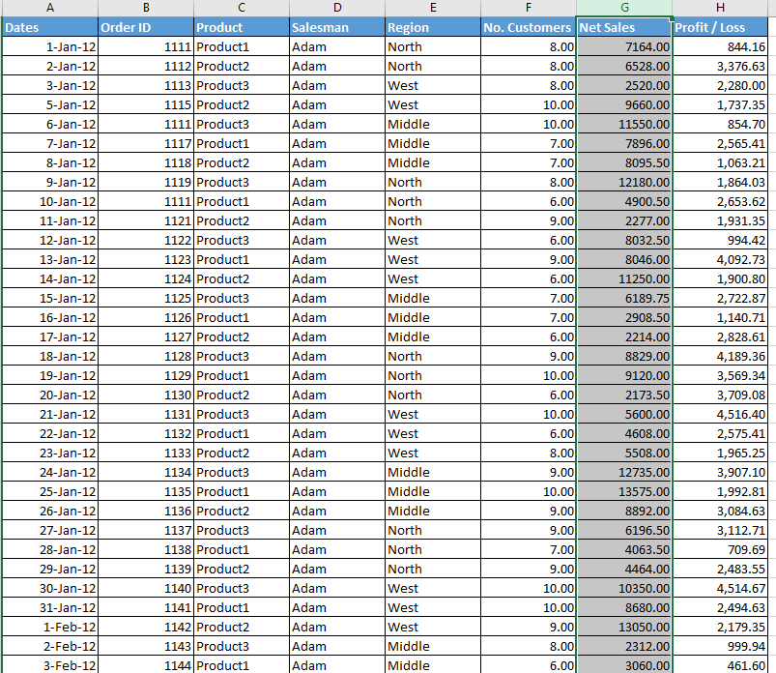

* 1. Click on **More Number Formats** under Format in the Home tab

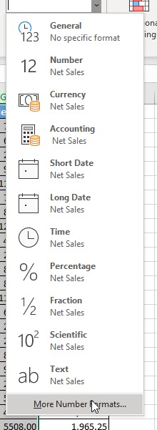

* 1. Choose Custom and type **#,##0.0,K** in the Type text box. Click on OK

* 1. The formatted numbers appear as shown:

